**ORCHARD HOUSE WELCOME STRICTLY DANCE IOW FOR FATHER’S DAY PERFORMANCE**

[16th June 2025](https://www.islandecho.co.uk/orchard-house-welcome-strictly-dance-iow-for-fathers-day-performance/)

in [**Local Community News**](https://www.islandecho.co.uk/category/community/)

[[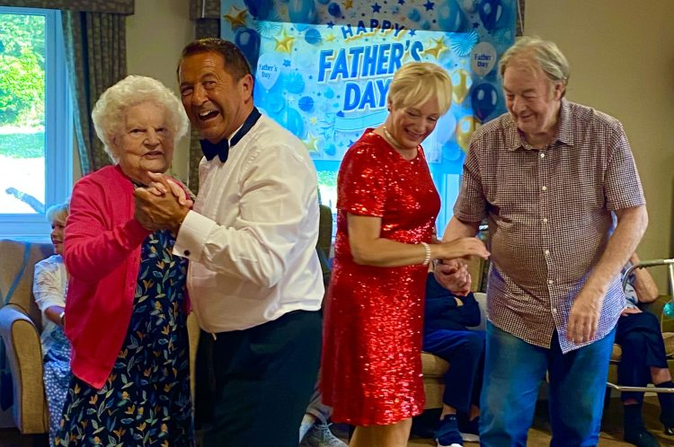](https://cdn.islandecho.co.uk/uploads/2025/06/Orchard-House-2.jpg)](https://cdn.islandecho.co.uk/uploads/2025/06/Orchard-House-2.jpg)

**Orchard House Care Home welcomed the talented dancers of Strictly Dance IOW for a stunning performance on Father’s Day (15th June).**

This event was arranged by Chantelle and Juliette, daughters of resident Keith.

Keith, a former dance instructor, was given a heartfelt surprise as the dancers brought his passion for dance back to life. The performance by Graeme and Sarah left smiles on everyone’s faces and was a poignant moment for Keith, filled with nostalgia and joy.

Graeme and Sarah also took the time to teach a few dance steps to Orchard House residents, who eagerly joined in.

Katie Schlepp, Head of Lifestyle said:

*“It was an honour to host such a meaningful and uplifting performance for Keith and all of our residents. Moments like these bring so much happiness and create lasting memories for everyone.”*